Insurance Claims Analysis
Task 1: Find claims where claim amount is greater than average claim amount
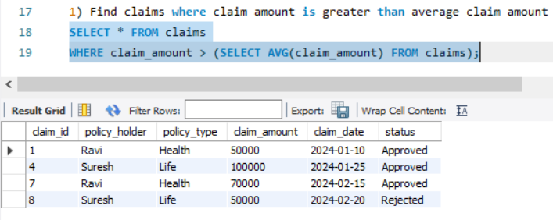
Task 2: Find policy holders who have at least one approved claim
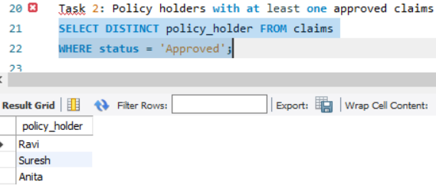
Task 3: Find claims where claim amount is greater than that policy holder’s average claim
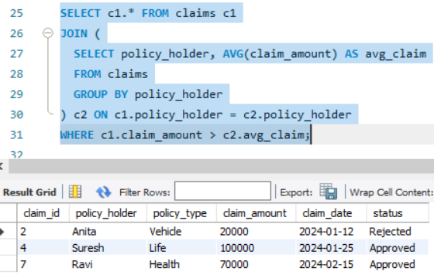

Task 4: Display each claim along with overall average claim amount
